# CHAPTER 1 : INTRODUCTION

## 1.1 Introduction

"Welcome to our Online Grocery Shopping project, where convenience meets quality. Our platform offers a vast array of products, from fresh produce to household essentials, all accessible at your fingertips. Say goodbye to long queues and heavy bags – shop comfortably from home, schedule convenient deliveries, and enjoy a seamless, secure shopping experience. We're dedicated to ensuring top-notch quality, timely deliveries, and evolving features that enhance your shopping journey. Join us as we redefine how you shop for groceries!"

## 1.2 Existing System

In the existing system all the works were done manually. The following paragraph describes the some terms which is related with this system i.e. how they works The user can have a limited warranty over the products and can claim for the same if the product displays any manufacture defects in the warranty period. Thus, the customer can claim for a free repair or replacement depending on the situation. The company provides regular paid and unpaid maintenance activities so as to ensure that the products functions well at all times. Paid maintenance activities initiate when the system showcases errors that don’t get covered in the Free Maintenance Period.

## 1.3 Need for System

An effective online grocery store software system should prioritize user experience through an intuitive interface and seamless navigation. It must manage a diverse product catalog, track inventory in real-time, and integrate secure payment gateways for safe transactions. Efficient order processing, delivery logistics, and customer accounts are essential, as is mobile compatibility for wider accessibility. Marketing tools, robust analytics, and customer support ensure engagement and satisfaction. Security measures, scalability, compliance with regulations, and seamless integration with other systems complete the framework, fostering a reliable and growth-oriented platform for online grocery retail.

**1.4 Operating Environment Hardware and Software**

**Software Requirements**

* Operating system : Windows XP/07/08/10.
* Coding Language : JAVA/J2EE
* IDE : Eclipse Kepler
* Database : MYSQL

**Hardware Requirements**

* CPU : Intel Core 2 Duo
* Ram : 2 GB ▪ HDD – 40 GB
* Extra : Monitor, Mouse, Keyboard

# CHAPTER 2 : PROPOSED SYSTEM

## 2.1 Proposed System

The proposed system uses the computers for all the operations i.e. for information storage, retrieval of data, updating records and maintain sessions for visitors etc. The main difference in existing and our system is that computers are being used all the working is faster and accurate. It also avoids the data redundancy. There is no question of changing of data stores, so it is also easy to maintain the data for longer period of time. As computer does all the calculations the report generation is automatic for each month or year hence reducing possibilities of errors in the calculation of premium, revival payment, maturity amount.

## 2.2 Module specifications

* Admin register Module
* Customer register Module.
* Customer Login module.
* Payment Module.

## 2.3 Scope

It can be used to maintain the details of –

* Customers
* Products
* Product Warranty
* Maintenance

❖ The facilities available in this system are:-

* Maintaining records of customers.
* Maintaining all the product details.
* Maintaining details of all maintenance period of customers.
* Viewing details of all the above whenever required.
* Sorting of data for the specified month or years.
* Report Generation for Maintenance Date, Warranty, Payment Details.

In this system collection of information is from different sources like customers and products. Details of customers and products can be updated in the database. The system operator can retrieve the information just by specifying the Customer Number of the customer about whom they want the information

## 2.4 Objectives of System

The primary objectives of an online grocery store project revolve around delivering convenience and accessibility through a user-friendly platform offering a wide array of products with efficient order processing and secure payment methods. Prioritizing exceptional customer service, effective marketing strategies, and continuous performance tracking aims to ensure customer satisfaction, engagement, and business growth. Scalability, innovation, reliability, and optimized performance constitute the core pillars, enabling expansion and the constant enhancement of user experience while maintaining a dependable and responsive platform.

# CHAPTER 3 : ANALYSIS & DESIGN

## 3.1 Entity Relationship

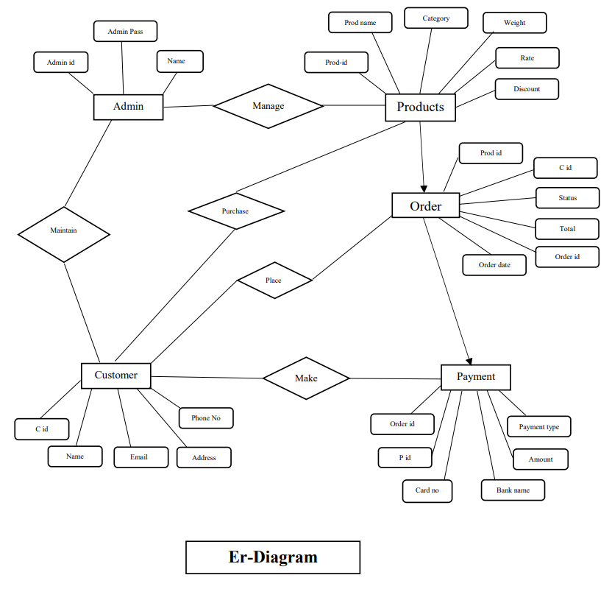

## 3.2Use Case Diagram

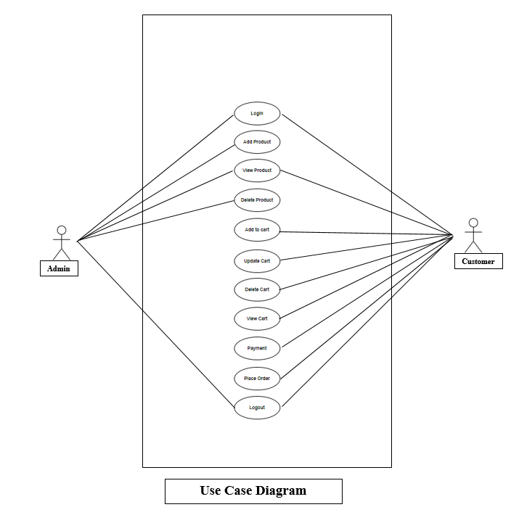

### 3.3 Activity Diagram

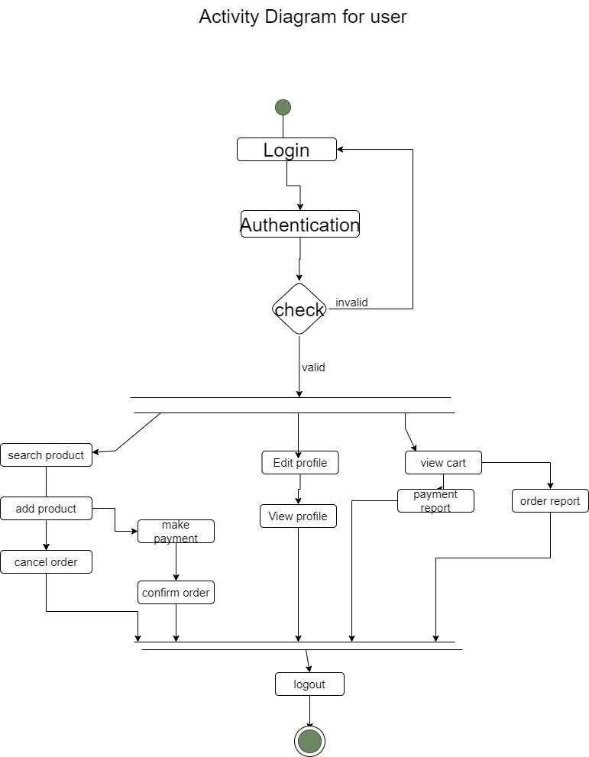

### 3.4 Class Diagram

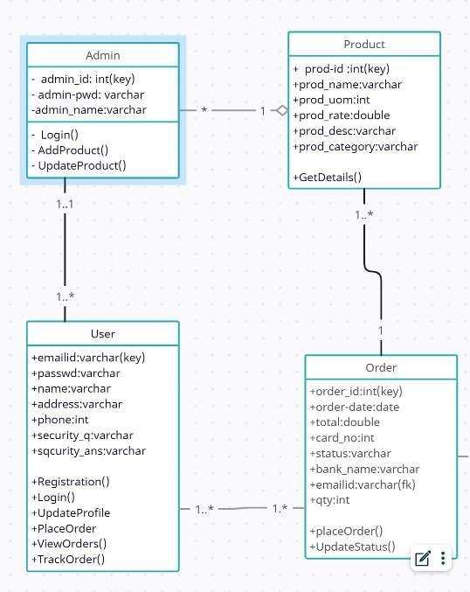

### 3.5 Module Hierarchy Diagram

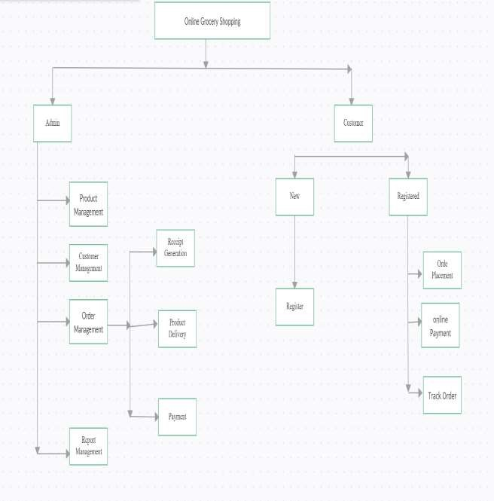

### 3.6 Tabel Specifications (Database design)

1. **Table Name: Admin**

**Description: information about admin**

**Primary key: admin_id**

|  |  |  |  |  |
| --- | --- | --- | --- | --- |
| **Field Name** | **Data Types** | **Size** | **Constraint** | **Description** |
| admin_id | varchar | 255 | Primary key | Generate Admin Id |
| admin_name | varchar | 255 | Not Null | Used for save admin name |
| Admin_pwd | varchar | 10 | Not Null | Used for save admin password |

1. **Table Name: users**

**Description: Information about Users.**

**Primary key: email_id**

|  |  |  |  |  |
| --- | --- | --- | --- | --- |
| **Field Name** | **Data Types** | **Size** | **Constraint** | **Description** |
| emailid | varchar | 255 | Primary key | Generate User id |
| passwd | varchar | 255 | Not null | Used for save User password |
| name | varchar | 255 | Not null | Used to save name of user |
| address | varchar | 255 | Not null | Used to save address of user |
| phone | varchar | 255 | Not null | Used to save user  Phone no |
| security_q | varchar | 255 | Not null | Select security Que |
| security_ans | varchar | 255 | Not null | Used to save answer |

1. **Table Name: products**

**Description: information about Products which is handled by admin**

**Primary key: Prod_id**

|  |  |  |  |  |
| --- | --- | --- | --- | --- |
| **Field Name** | **Data Types** | **Size** | **Constraint** | **Description** |
| prod_id | int | - | Primary key | Generate prod id |
| prod_name | varchar | 255 | Not null | Used to save  Product name |
| prod_uom | varchar | 255 | Not null | Used to save uom |
| prod_rate | float | - | Not null | Used to save product rate |
| prod_desc | float | - | Not null | Used to save product discount |
| prod_category | varchar | 255 | Not null | Used to save product category |

1. **Table Name: order_master**

**Description: information about Order (admin)**

**Primary key: order_id**

|  |  |  |  |  |
| --- | --- | --- | --- | --- |
| **Field**  **Name** | **Data Types** | **Size** | **Constraint** | **Description** |
| order_id | int | - | Primary key | Generate order_id id |
| order_date | date | - | Not null | Used to save date of order |
| total | float | - | Not null | Used to save total |
| status | varchar | 255 | Not null | Used to save status |
| card_no | varchar | 255 | Not null | Used to save card no |
| bank_name | varchar | 255 | Not null | Used to save bank name |
| emailid | varchar | 255 | Foreign key | Used to save Email id |

1. **Table Name: order_details**

**Description: information about Orders(user)**

**Primry key: prod_id**

|  |  |  |  |  |
| --- | --- | --- | --- | --- |
| **Field**  **Name** | **Data Types** | **Size** | **Constraint** | **Description** |
| prod_id | Int | - | FOREIGN  KEY | Used to save prod_id |
| qty | int | - | - | Used to save quantity |
| order_id | int | - | FOREIGN  KEY | Used to save order_id |

### 3.7 Data Dictionary

|  |  |  |  |  |  |
| --- | --- | --- | --- | --- | --- |
| **Sr No** | **Field**  **Name** | **Descripton** | **Data Type** | **Constraint** | **Table**  **Name** |
| **1** | admin_id | Enter admin id | varchar | Primary key | **Admin** |
| admin_na  me | Enter admin name | varchar | Not Null |
| Admin_p wd | Enter admin password | varchar | Not Null |
|  |  |  |  |
| **2** | Id | Enter user emailid | varcha e | Primary key | **users** |
| passwd | Enter the password | varchar | Not null |
| name | Enter  name of  user | varchar | Not null |
| address | Enter address of user | varchar | Not null |

|  |  |  |  |  |  |
| --- | --- | --- | --- | --- | --- |
|  | phone | Enter Phone number | varchar | Not null |  |
| security_  q | Select security Question | varchar | Not null |
|  | security_  ans | Enter to save answer | varchar | Not null |  |
|  |  |  |  |  |  |
| **3** | prod_id | Enter product id | int | Primary key | **products** |
| Prod_na me | Enter product name | varchar | Not null |
| prod_uo  m | Enter  Unit of measure ment | varchar | Not null |
| prod_rate | Enter product rate | varchar | Not null |

|  |  |  |  |  |  |
| --- | --- | --- | --- | --- | --- |
|  | prod_des c | Enter product discount | varchar | Not null |  |
| prod_cate  gory | Select product category | varchar | Not null |
| **4** |  |  |  |  | **order_ master** |
| order_id | Enter order id | int | Primary key |
| order_dat e | Enter date | varchar | Not null |
| total | Enter total | varchar | Not null |
| status | Enter status | varchar | Not null |
| card_no | Enter card no | varchar | Not null |
| bank_na  me | Enter bank name | varchar | Not null |
| emailid | Enter Emailid | varchar | Foregin key |
|  |  |  |  |  |
| **5** | prod_id | Enter prod id | int | Foreign key | **order_**  **details** |
| qty | Enter quantity | int | Not null |
| order_id | Enter order id | varchar | Foreign key |
|  | New password | Enter new pass | varchar | Not null |
|  |  |  |  |  |

# 3.8 Test Cases

|  |  |  |  |  |  |  |  |  |  |
| --- | --- | --- | --- | --- | --- | --- | --- | --- | --- |
| **Test**  **Case id** | **Test objective** | **Pre**  **condition** | | **Steps** | **Test data** | **Expected result** | **Post**  **condition** | **Actual**  **result** | **Pass/**  **fail** |
| TC0  01 | Verify custom er login with id and  Password | Customer should be registered with valid id and  password before login. | | Click on login button. Enter valid id and password. | ID: raj@gmail.com  Pass:-12345 | System display s home page. | Custom er should be kept logged in until logout. | As  expected, | Pass |
| TC0  02 | Verify customer login | Customer is not  registered with valid | | Click on login button. | Id:  000  Password: 588 | Display alert box. | Redirect to  lo gin page | As expected | Pass |
|  | with invalid id and  valid password | id and password. | | Enter valid id and password |  | Invalid id |  |  | fail |
| TC0  03 | Verify custom er login with valid id  and  invalid  password | Customer is not  registered with valid id and  password | | Click on login button. Enter valid id and password | Id:  raj@gmail.com  Pass:-7878 | Display alert box. Invalid password. | Redirect to  Login page. | As expect ed | Pass |
| TC0  04 | Verify Customer  login with id and password | User should be  registered with valid id and password before login | | Click on login button. Enter valid id and password. | Id:  raj@gmail.com Pass:12345 | System displays home page | User should  Be kept logged in until logout. | Display home page | Pass |
| TC0  05 | Verify login with invalid id and  valid password | artist is not registered  with valid id and password. | | Click on login button. Enter valid id and  password | Id:  rak@gmai.com Pass:12345 | Display alert box. Invalid  id | Redirect to  loginpage | Invalid Id | Pass |
| TC0 06 | Home page | U | User should be logged in | Click shop now or login. | N/A | Display  all  Products | User should be logged in. | Display all  products | Pass |
| TC0 07 | Add to Cart | U | Must logged be logged in. | Select the required  products  . | Rice | Products  shown in cart. | User must be logged in. | Display products in Cart. | Pass |
| TC0 08 | Remove  From  cart  Products . | User must be logged in. | | Click on products  to remove. | apple | Product is  removed  . | User must be logged in. | Product is  removed  . | Pass. |

# CHAPTER 4 : USER MANUAL

**4.1 User Interface Screens (Input)**

## Home Page

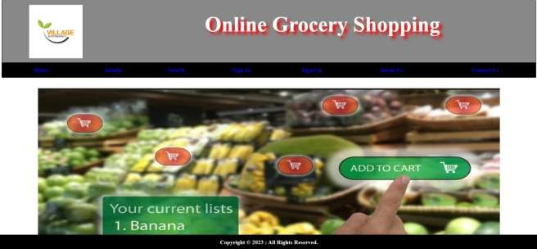

## Admin Login

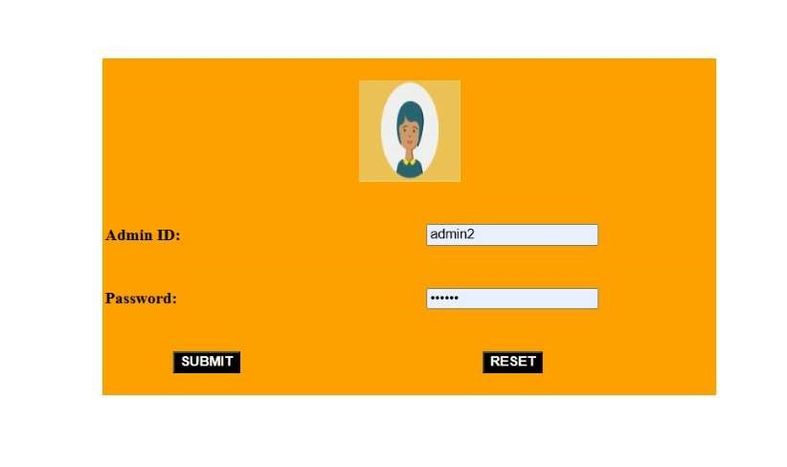

## Admin Home Page

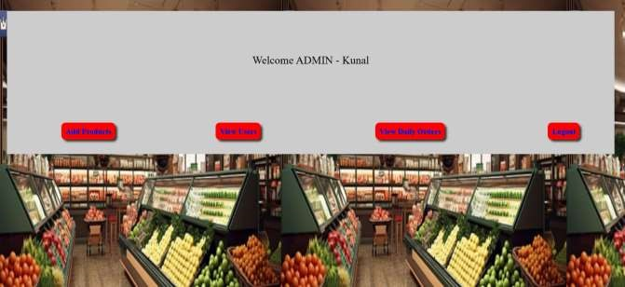

## Admin add prod

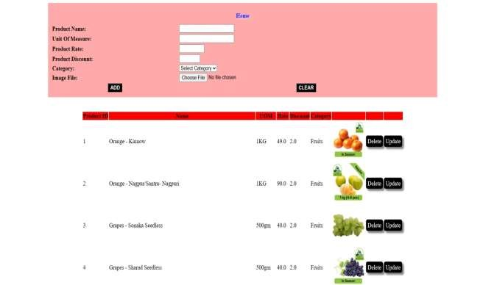

## Update Product

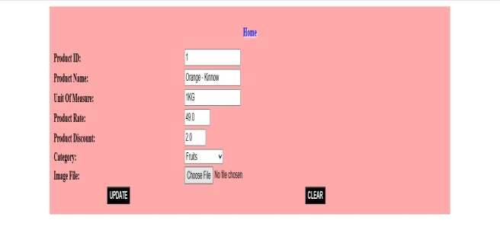

## Admin – View Users

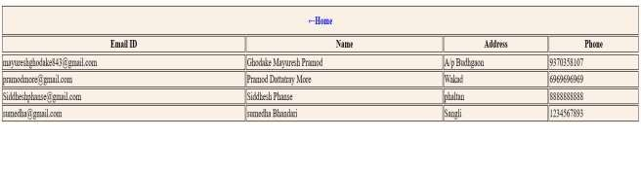

## Admin - View Daily Order

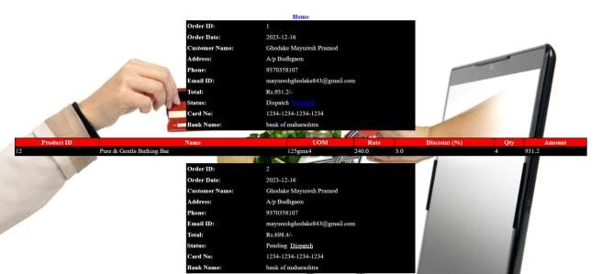

## User sign in

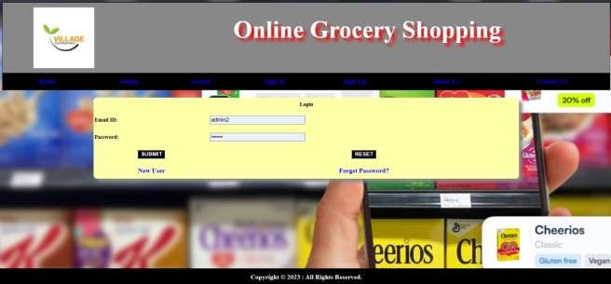

## Registration

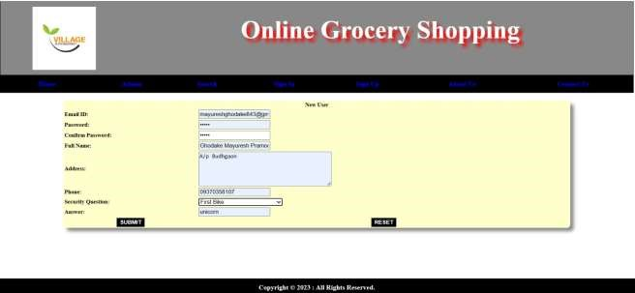

## User – Home Page

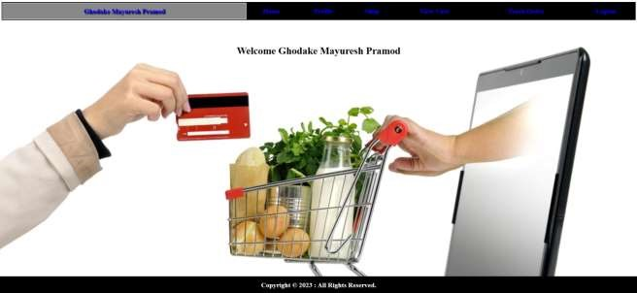

## User – Edit Profile

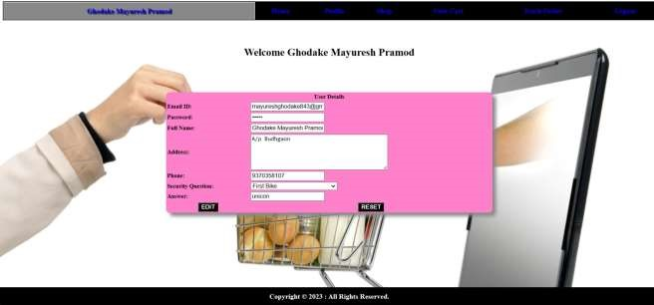

## Search Product

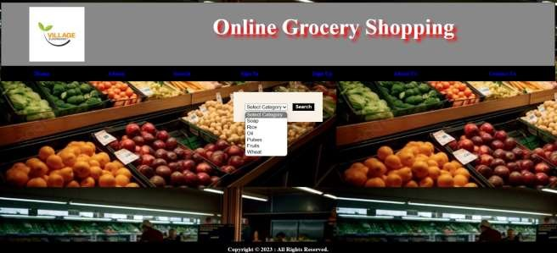

## Track order user

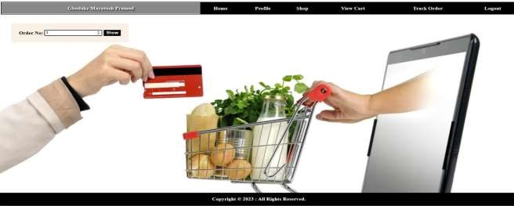

## Add to cart

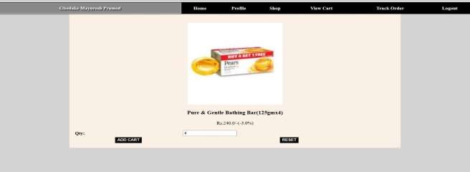

## View cart

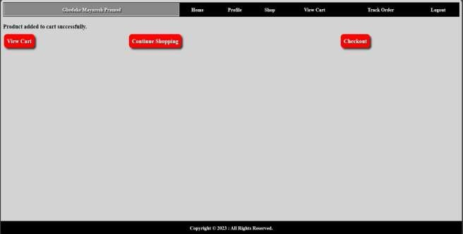

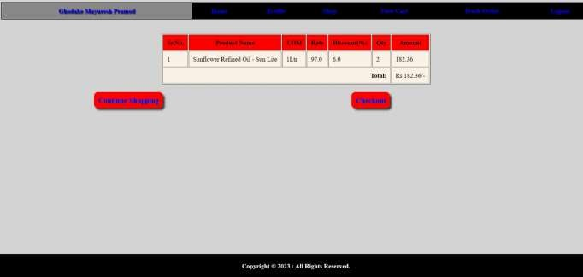

## Payment

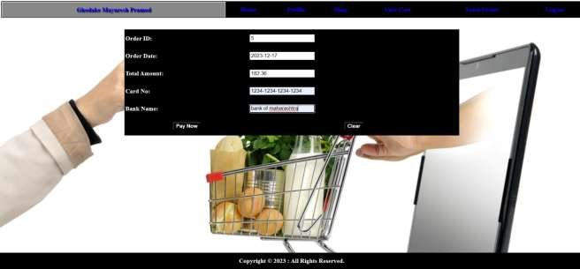

## Track Order

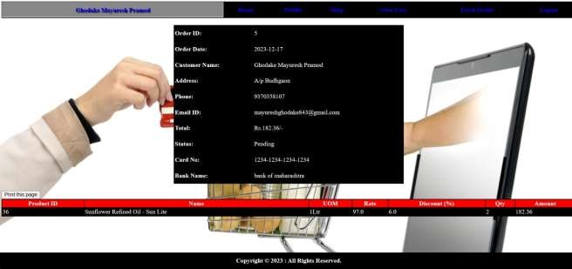

## 4.3 Data Reports

### Admin activity:-

**1. View User**



**2 .View Order Details**

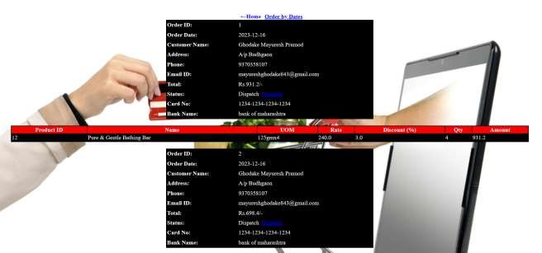

### Customer activity :-

#### 1. View Cart

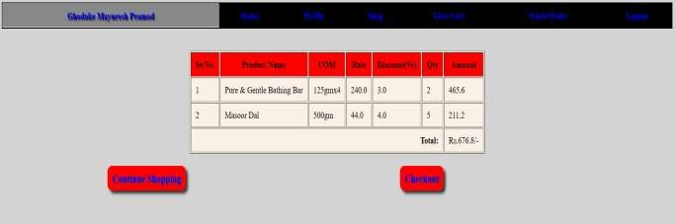

# 2. track Order

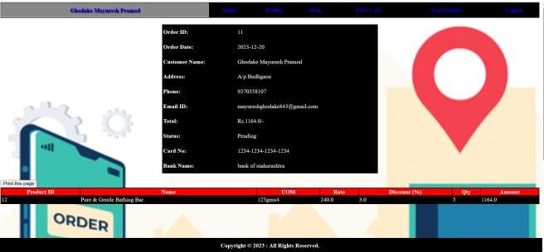

## 4.4. Sample Project Code

### Index.jsp:-

<script type="text/javascript"> var currentPos = 0; var images = [ "back1.jpg", "back2.jpg", "back6.png", "back4.jpg",

"back5.jpg" ]

function change() {

document.getElementById("image").src = "images/" + images[currentPos]; currentPos = (currentPos + 1) % images.length;

}

setInterval("change()", 3000);

</script>

<body bgcolor='white' style='margin-bottom: 100px;'>

<header>

<jsp:include page="header.html"></jsp:include>

</header>

<article style='padding: 30px;'>

<center>

<img id="image" src="images/back1.jpg" width='90%' height='90%'> </center>

</article>

<footer>

<jsp:include page="footer.html"></jsp:include> </footer></body>

### AddProduct.jsp:-

<link rel='stylesheet' type='text/css' href='css/style.css'>

<form method='post' action='http://localhost:8080/Online_Grocery_Shop/AddProductServlet' name='add' enctype="multipart/form-data">

<table align='center' width='80%' style='background:#FAA;padding:10px;'> <tr>

<td colspan=2 align='center' style='padding:10px;'><a href='admin_home.jsp' class='menu1'>Home</a></td>

</tr>

<tr>

<td><b>Product Name:</b></td>

<td><input type='text' name='pname' required></td>

</tr>

<tr>

<td><b>Unit Of Measure:</b></td>

<td><input type='text' name='uom' required></td>

</tr>

<tr>

<td><b>Product Rate:</b></td>

<td><input type='number' name='prate' min=10 max=5000 required></td>

</tr>

<tr>

<td><b>Product Discount:</b></td>

<td><input type='number' name='pdisc' min=0 max=71 required></td>

</tr>

<tr>

<td><b>Category:</b></td>

<td>

<select name='cat' required>

<option value=''>Select Category</option>

<option value='Soap'>Soap</option>

<option value='Rice'>Rice</option>

<option value='Oil'>Oil</option>

<option value='Pulses'>Pulses</option>

<option value='Fruits'>Fruits</option>

<option value='Wheat'>Wheat</option>

</select>

</td>

</tr>

<tr>

<td><b>Image File:</b></td>

<td><input type="file" name="pimg" id="fileToUpload"></td>

</tr>

<tr>

<td align='center'><input type='submit' value='ADD' class='btn'></td>

<td align='center'><input type='reset' value='CLEAR' class='btn'></td>

</tr>

</table><br>

</form>

<%@page import="java.sql.*"%>

<%

Class.forName("com.mysql.cj.jdbc.Driver");

Connection con = DriverManager.getConnection(

"jdbc:mysql://localhost:3306/shop", "root", "root");

Statement s = con.createStatement();

ResultSet rs = s.executeQuery("select * from products order by prod_id");

%>

<table align='center'>

<tr bgcolor='red'>

<th>Product ID</th>

<th>Name</th>

<th>UOM</th>

<th>Rate</th>

<th>Discount</th>

<th>Category</th>

<th></th>

<th></th>

<th></th>

</tr>

<%

while(rs.next())

{

%>

<tr>

<td><%=rs.getString(1)%></td>

<td><%=rs.getString(2)%></td>

<td><%=rs.getString(3)%></td>

<td><%=rs.getString(4)%></td>

<td><%=rs.getString(5)%></td>

<td><%=rs.getString(6)%></td>

<td><img src='images/<%=rs.getString(1)%>.jpg' width='100px' height='100px'/></td>

<td><a href='del_product.jsp?pid=<%=rs.getString(1)%>' style="text-

decoration:none;background:black;color:white;padding:5px;border-radius:5px;box-shadow:5px

5px 5px grey;">Delete</a></td>

<td><a href='update_product.jsp?pid=<%=rs.getString(1)%>' style="text-

decoration:none;background:black;color:white;padding:5px;border-radius:5px;box-shadow:5px 5px 5px grey;">Update</a></td>

</tr>

<%

}

%>

</table>

## 4.5 Limitations and Bibliography

**Limitations :-**

**Technical issues:** Online grocery shopping can be subject to technical issues, such as website outages or order errors.

**Lack of personal interaction:** You can't get the same level of personal interaction and customer service from an online grocery store as you can from a traditional brick-and-mortar store.

**Environmental impact:** Online grocery shopping can have a larger environmental impact than traditional grocery shopping, due to packaging, transportation, and food waste.

### Reference Books :-

* **Learning Web Design:** A Beginner's Guide to HTML, CSS, JavaScript, and Web Graphics.
* HTML and CSS Quick start Guide.
* **Get Coding!:** Learn HTML, CSS & JavaScript & Build a Website, App &Game

– by Young Rewired State

### Reference Website :-

* Amazon Fresh:<https://www.amazon.com/amazonfresh>
* Walmart Grocery:[https://grocery.walmart.com](https://grocery.walmart.com/)
* Instacart: [https://www.instacart.com](https://www.instacart.com/)